(better viewed on github)

How to use the tool -
Click the 'About' button in the top right to get basic information about the app.

If you want to report a collision:
- Click the 'Report collision' button at the top of the screen
- It will redirect you to a survey - fill it out to the best of your abilities. Scroll through the survey and you will see a map where you can click where the incident took place. Links are provided to better understand the official reporting channels and direct you there should you want to report that way as well.
- On your next loading of the map, your added point will be there!
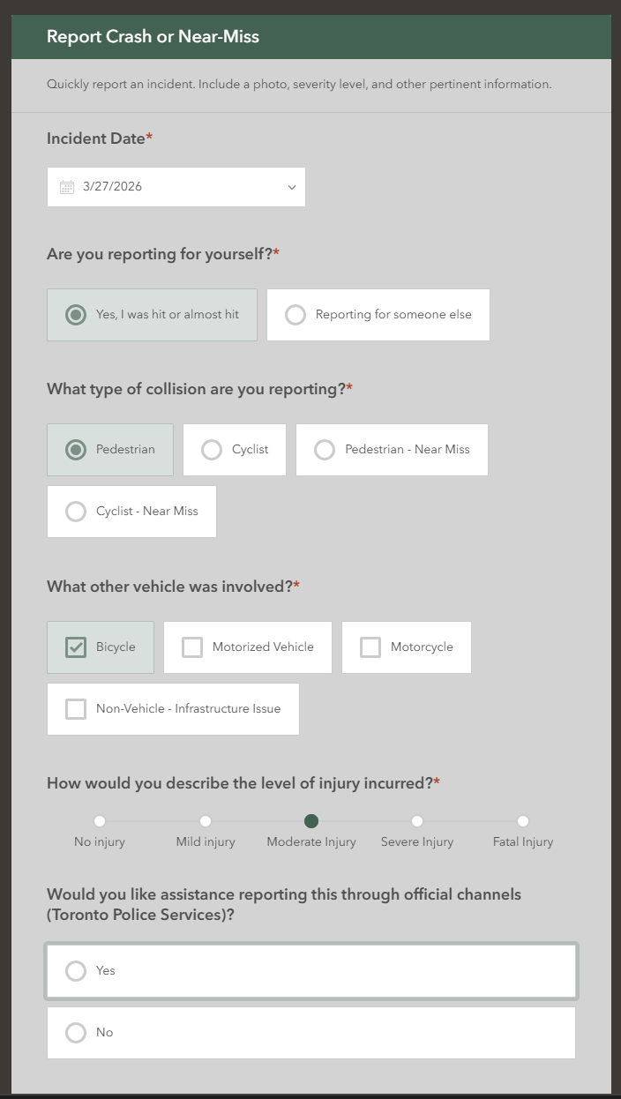

If you want to explore the map:
- Zoom in and out using the +/- buttons in the top left.
- Clicking and dragging can help move your view.
- The geocoder in the header (search bar) can help you find regions and locations in Toronto. Type in the name or address of where you are interested and hit ENTER. It will zoom you to what you need to see.
- The cycling network is included by default. Click on any of these lines to see what infrastructure exists there.
- Point data becomes visible at a higher zoom level! Click on these points to learn more.
- Click the 'Legend' widget in the bottom right to understand the map features.

If you want to change what is visible on the map:
- Click the 'Layer' widget in the bottom right to toggle on and off different layers. Check out the safety index!
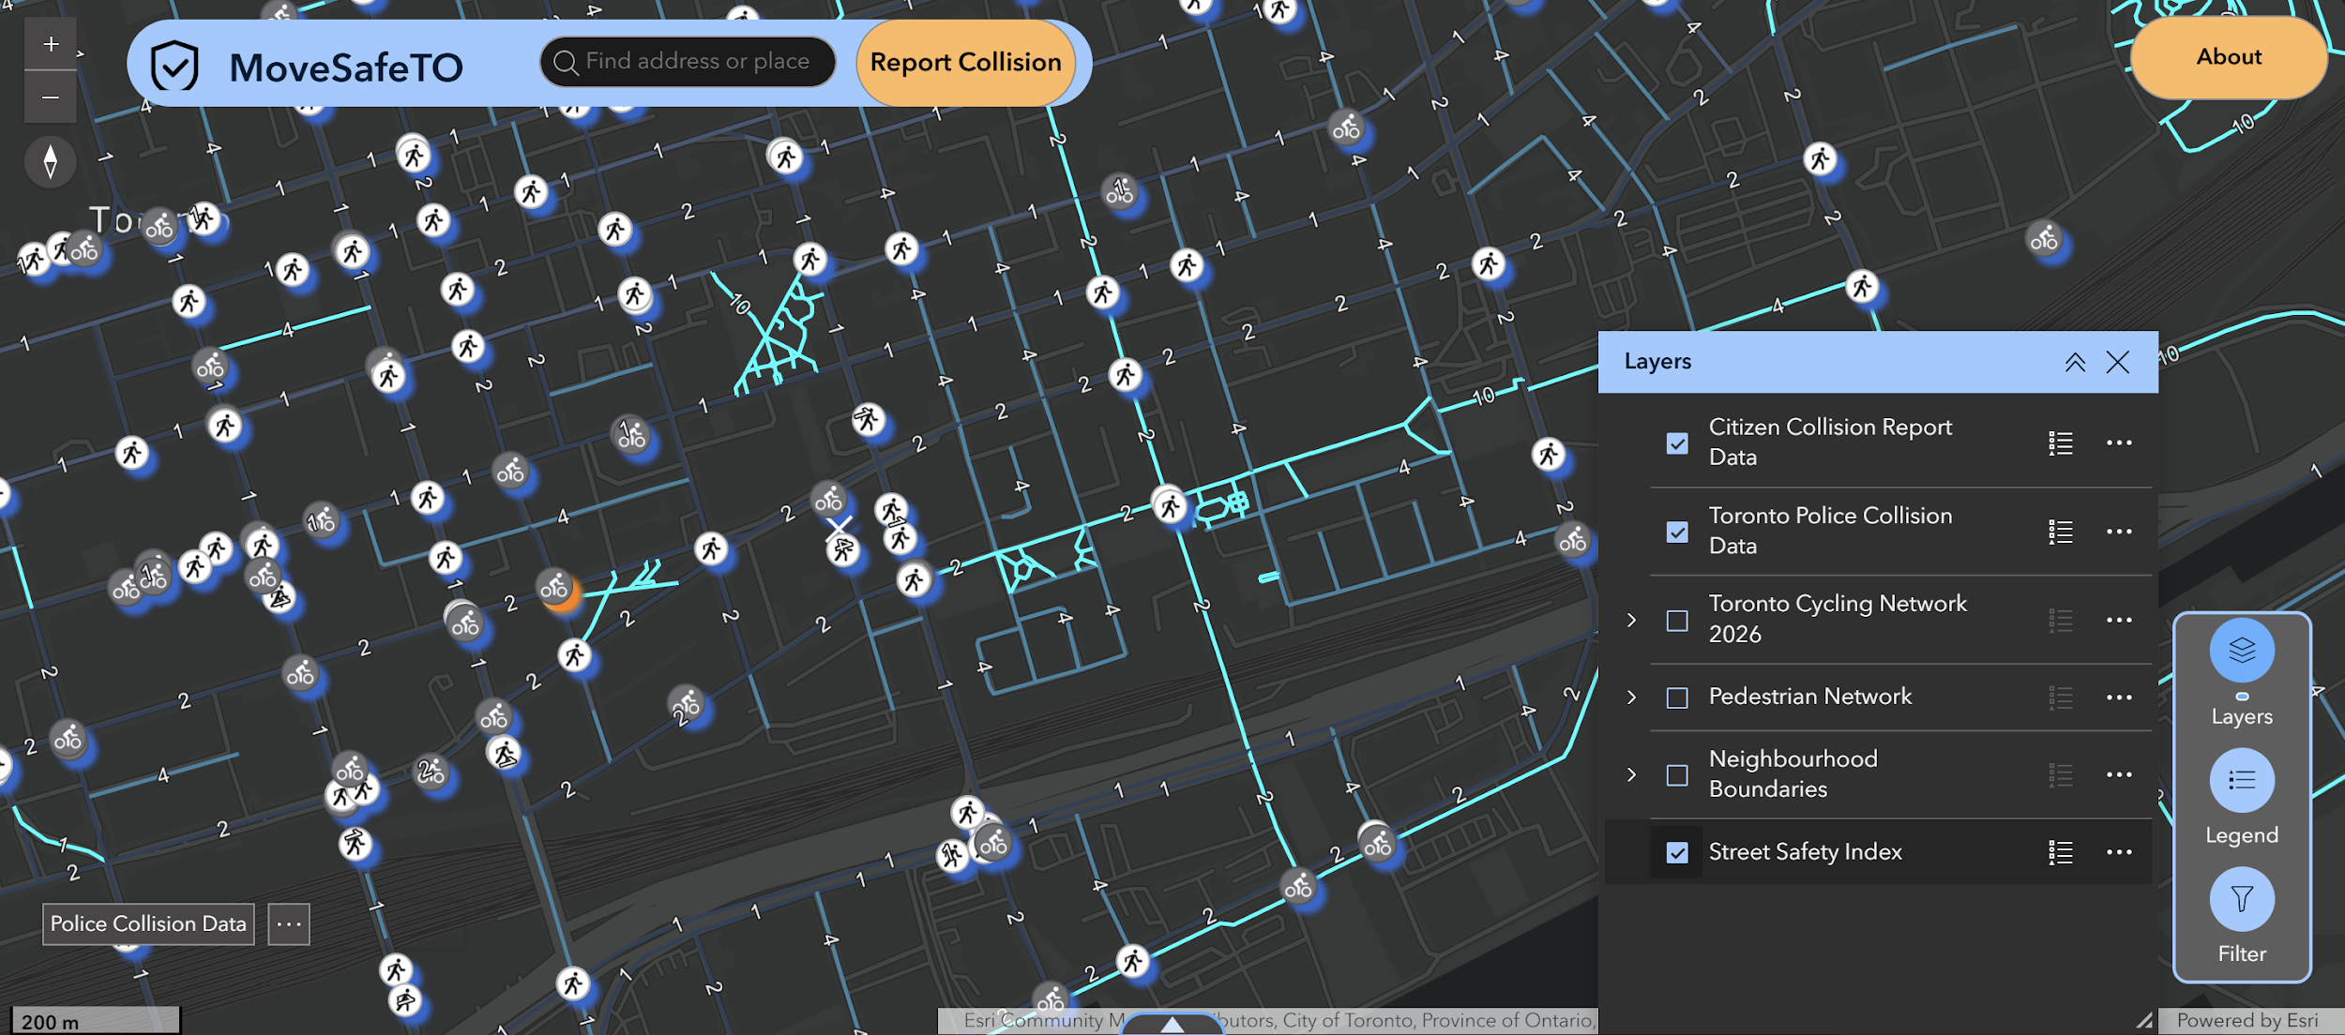
- Click the 'Filter' widget in the bottom right to change which types of data points you see. For police and citizen reports, you can filter to only view what is important to you - like only fatal collisions or only incidents of property damage.
- Click either of the buttons on the bottom left to perform a spatial query (check out data in a specific place) for collision points. You can fetch all the records that correspond to points in your view, draw a polygon on the map (double-click to finish drawing) and see all records within, or drop a point and define a buffer (radius) and see records contained in that circle. This is a great way to find data pertinent to you - are there lots of collisions around your school? How many are in your neighbourhood?
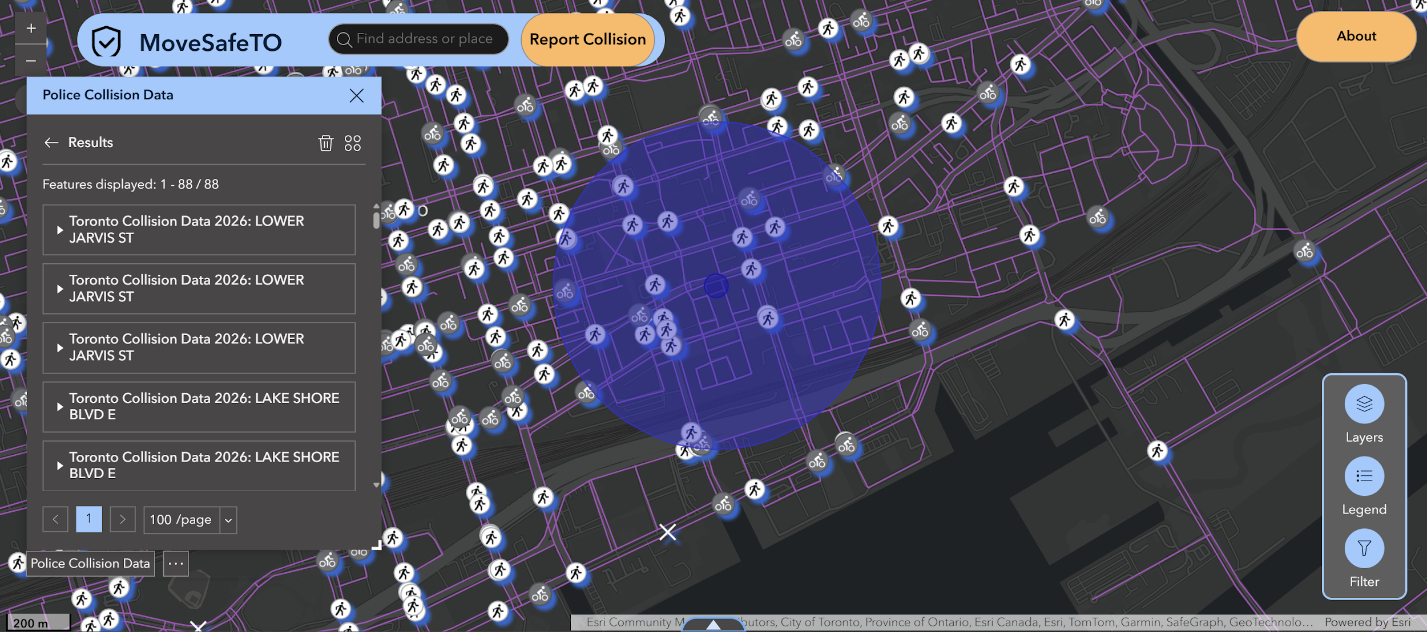

If you want to look at data trends:
- Click on the arrow at the bottom of the page in the center. This will open a half-screen with some more information for you!
- On the left are pie charts. Flip through them with the arrows on either side of the graph!
- On the right are bar charts. Flip between them both with arrows as well. These charts will answer questions like:
How many of these collisions were fatal? How many collisions involved bikes? What types of street infrastructure are most of these collisions happening at? How does road class interact with injury severity in the case of collisions?
